Prerequisites for FeedbackLoop
0 Download project archive Calypso-main.zip
1 Deploy application Calypso.TeamApp123 and get url like https://29d0-93-171-78-238.ngrok.io
2 Setup AAD app using instructions https://docs.microsoft.com/en-us/microsoftteams/platform/tabs/how-to/authentication/auth-aad-sso
3 Change ADD app resource uri to api://29d0-93-171-78-238.ngrok.io/{{{client-id}}}
4 Add redirect uri https://29d0-93-171-78-238.ngrok.io/auth-end.cshtml
5 Update appsettings of deployed app using ADD app data
6 Create storage account and update appsettings section Dependencies.AzureStorage
7 Set Planner and Team sections and update appsettings

INSTALLATION OF FEEDBACKLOOP APP IN MICROSOFT TEAMS
0 Download FeedbackLoop.zip
1 Create team and channel
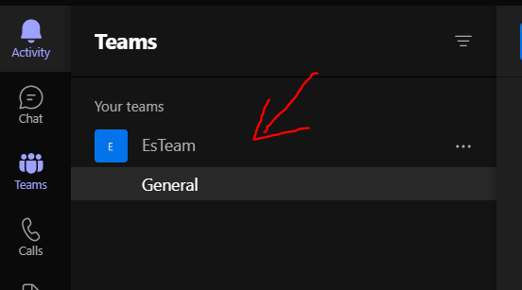
2 Install Tasks by Planner and To Do and create plan
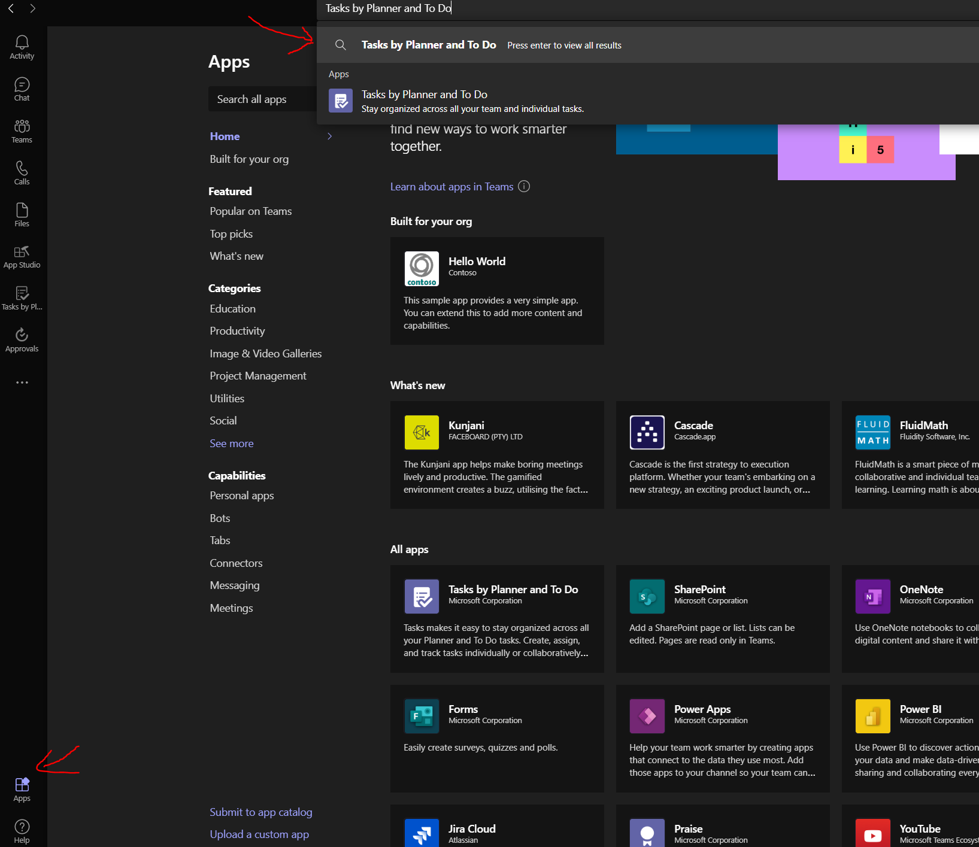
3 Deploy Api configured with Team, Channel and Plan
4 Deploy Web App
5 Install Microsoft Teams app AppStudio
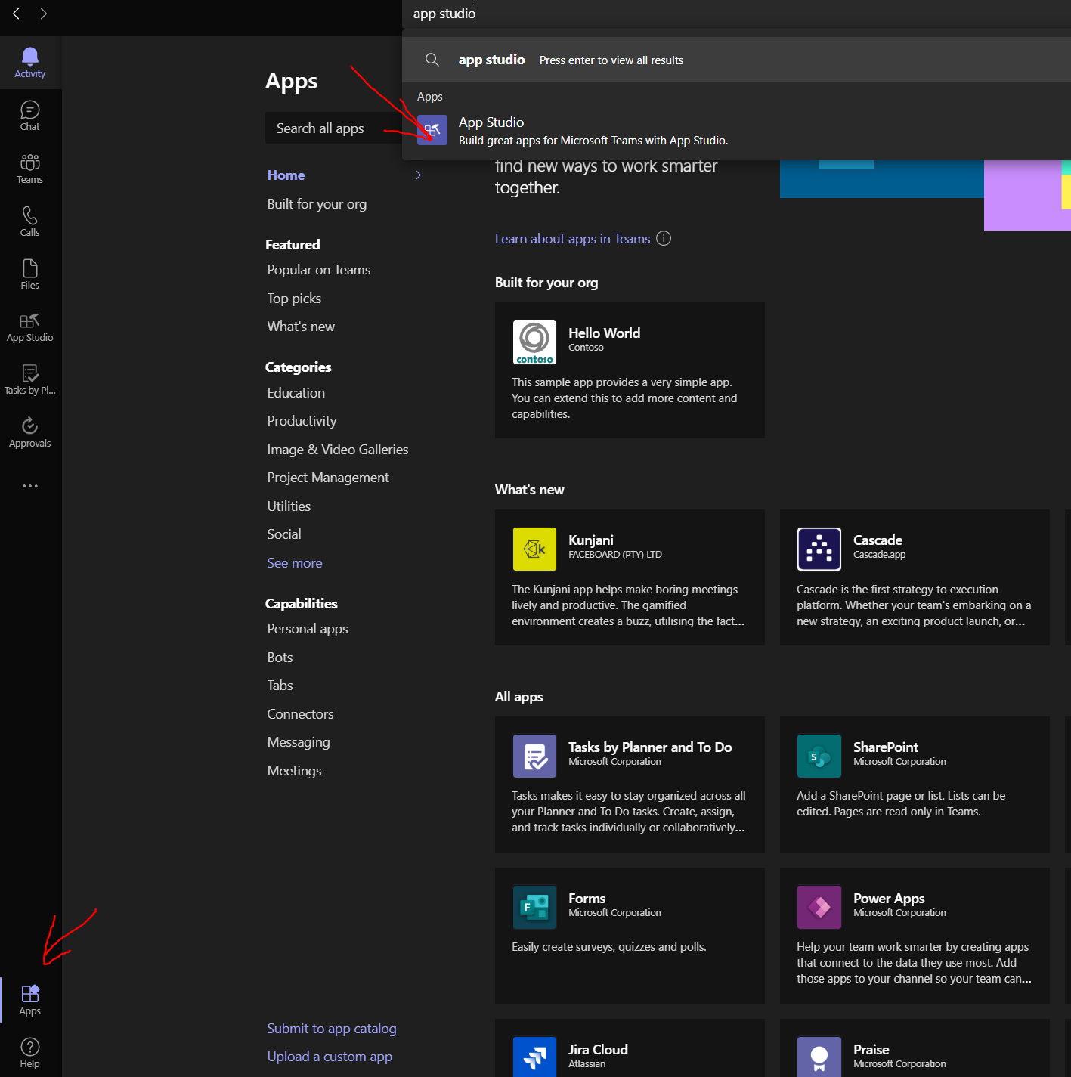

6 In AppStudio import app using FeedbackLoop.zip file
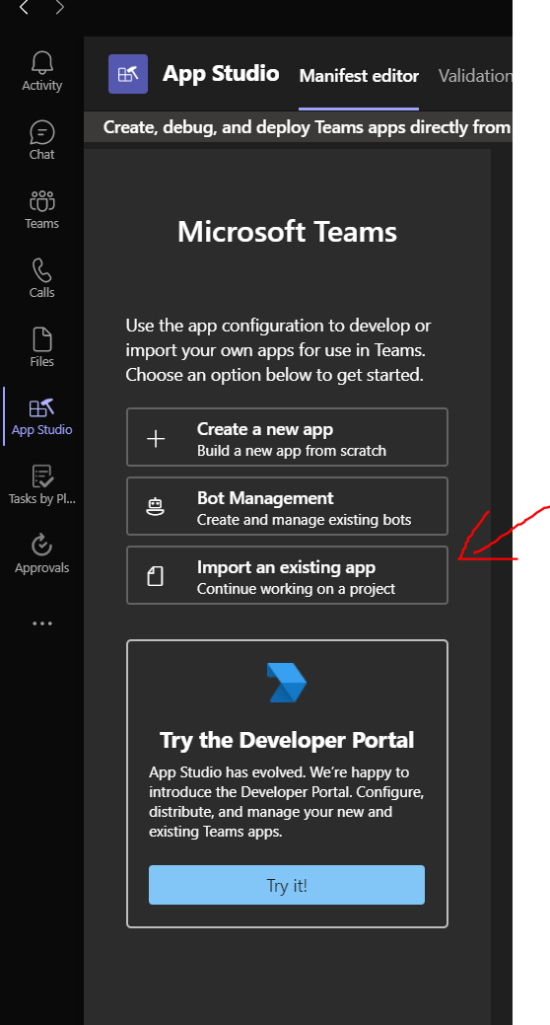

7 Fill App details
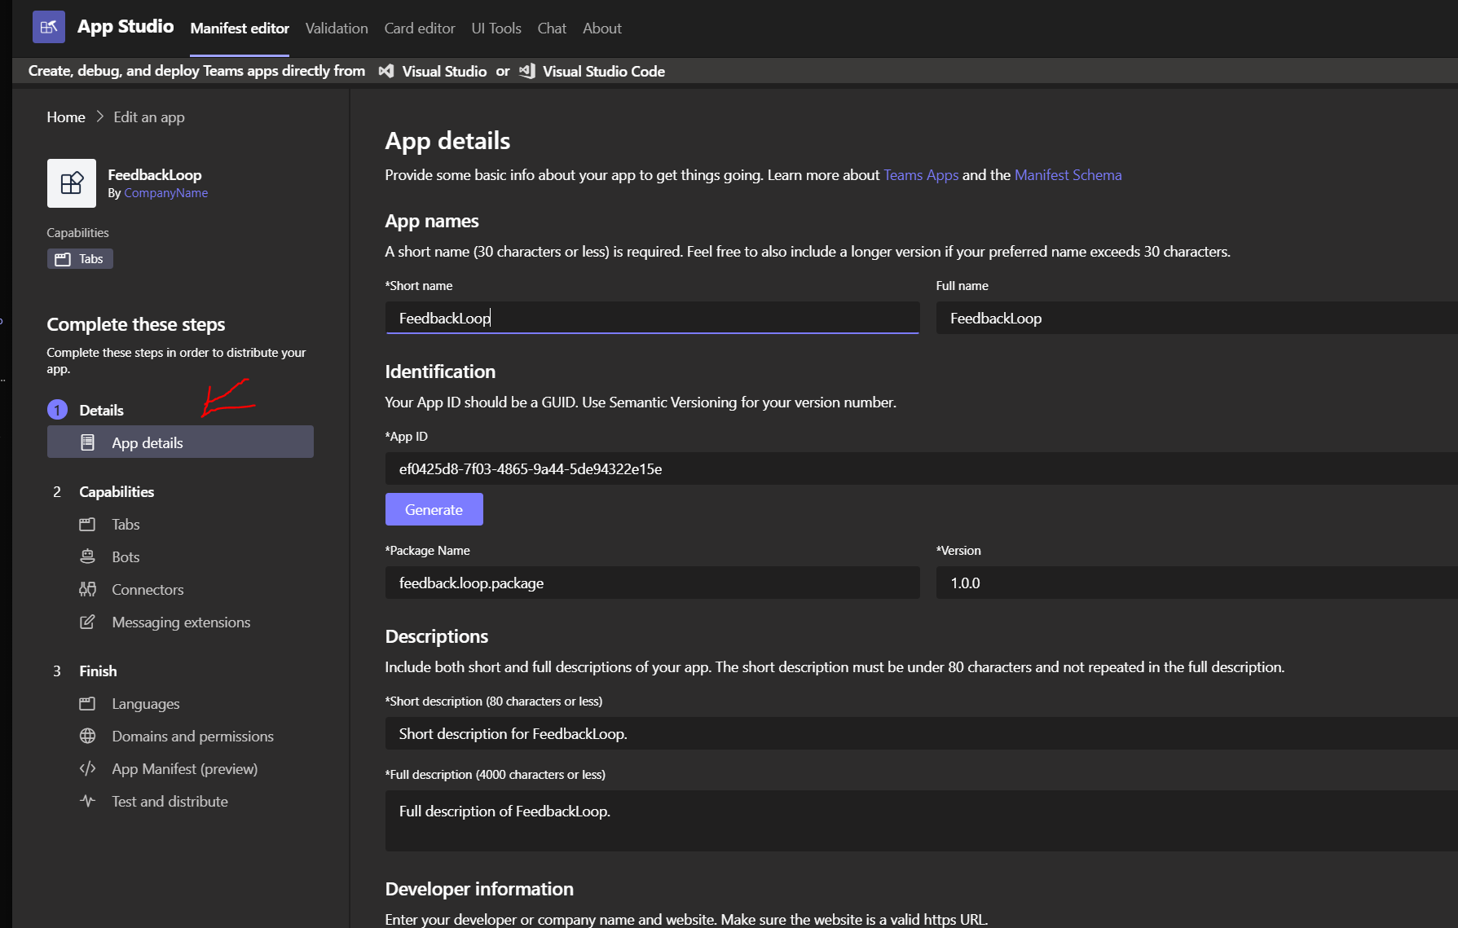
8 Fill configuration url(2) and content url (2) with urls of deployed web application
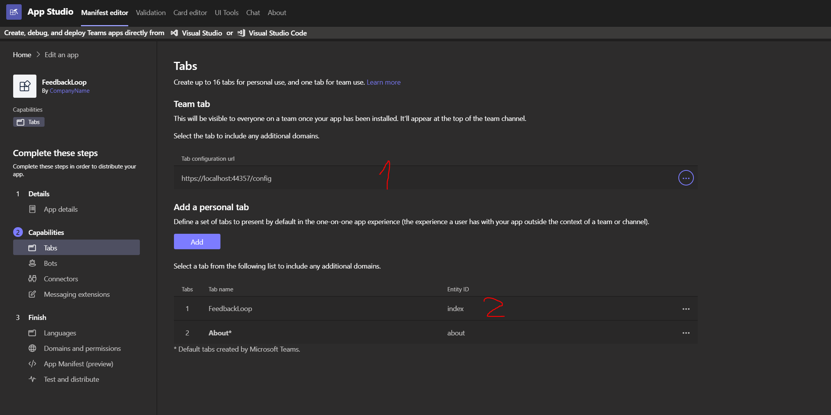

Fill domain and permissions using deployed app info and aad app info
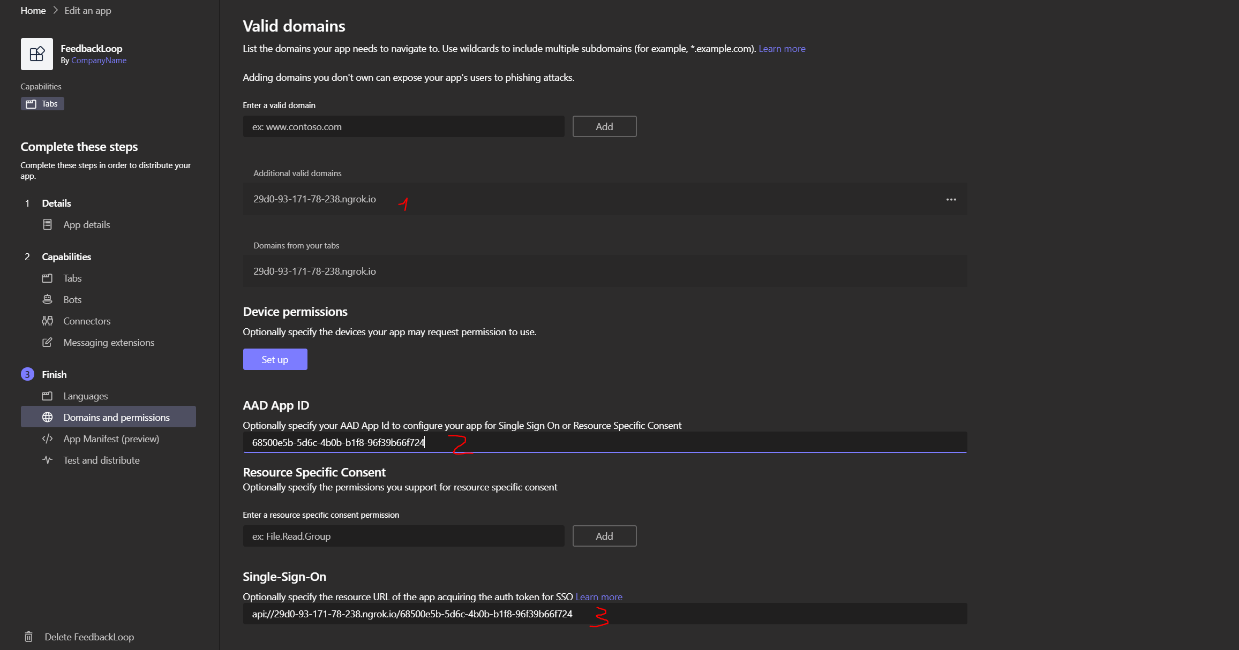

9 Go to Test and distribute -> install -> add to team → select a team -> setup a tab → save

